**Alunos: CAIO VINICIUS OLIVEIRA BRITO, GUIDO MARGONAR MOREIRA e GUILHERME YAMAMOTO KATO**

jdbc baixado aqui: [**https://www.oracle.com/br/database/technologies/appdev/jdbc-downloads.html**](https://www.oracle.com/br/database/technologies/appdev/jdbc-downloads.html)

**<<SQL DEVELOPER:>>**

**ALTER SESSION SET "_ORACLE_SCRIPT" = TRUE**

**CREATE USER CAIO2 IDENTIFIED BY "12345";**

**GRANT CONNECT,RESOURCE, UNLIMITED TABLESPACE TO CAIO2;**

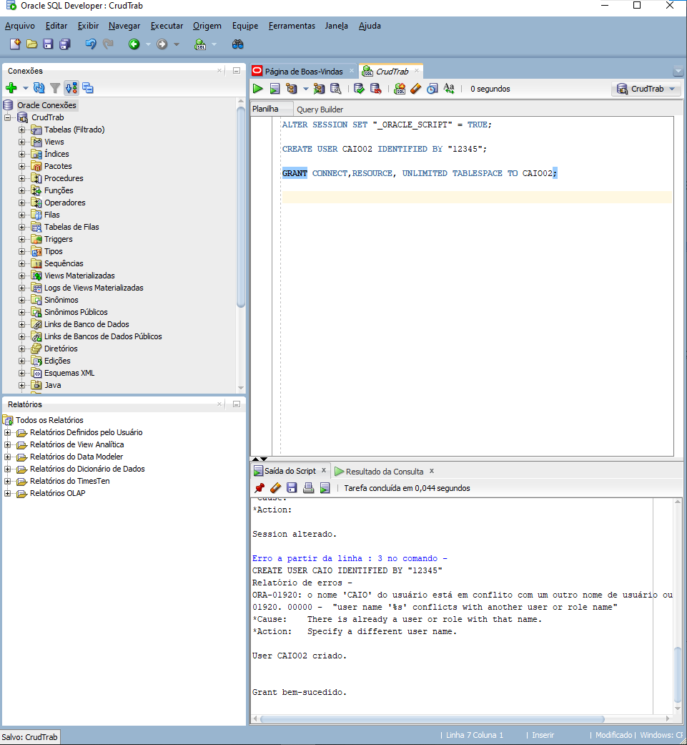**print <<SQL DEVELOPER:>>:**

**<<NETBEANS>>**

package crud;

import java.sql.*;

public class CRUD {

/**

* @param args the command line arguments

*/

public static void main(String[] args) {

Connection conexao = ObterConexao();

try{

Statement statement = conexao.createStatement();

String query = "SELECT sysdate FROM dual";

ResultSet resultSet = statement.executeQuery("select sysdate from dual");

if(resultSet.next()){

System.out.println(resultSet.getDate("sysdate"));

}

}catch(SQLException e){

e.printStackTrace();

}

}

private static Connection ObterConexao() {

Connection conexao = null;

try{

try{

Class.forName("oracle.jdbc.driver.OracleDriver");

conexao = DriverManager.getConnection("jdbc:oracle:thin:@localhost:1521:xe", "CAIO2", "12345");

}catch(ClassNotFoundException e){

e.printStackTrace();

}

}catch(SQLException e){

e.printStackTrace();

}

return conexao;

}

}

**print <<NETBEANS>>:**